Design of a small satellite radio beacon for Identification, Telemetry, Tracking and Control

Travis J McKee[1]

*The University of New South Wales at the Australian Defence Force Academy*

Well written abstract to be added here

# Contents *To be updated when complete*

1. Introduction 2
2. Aim 2
3. Background 3
4. The present study 4
5. Satellite radio beacon segment 3
   * + 1. Materials and methods 3
       2. Results 3
       3. Discussion 3
   1. Communications link 4
      * 1. Materials and methods 3
        2. Results 3
        3. Discussion 3
   2. Ground receiving segment 5
      * 1. Materials and methods 3
        2. Results 3
        3. Discussion 3
6. Conclusion 6
7. Recommendations 6
8. Acknowledgements 10

References 12

APPENDICES *To be updated when complete*

Appendix A. Arduino Pro Mini processor testing method and results A1

Appendix B. RFM96 LoRa radio module testing method and results B1

Appendix C. Satellite radio beacons software flow chart and design considerations C1

Appendix D. Satellite beacon electrical power regulation testing method and results D1

Appendix E. Total beacon electrical power requirements and generation testing method and results E1

Appendix F. Satellite beacon electrical power storage testing method and results F1

Appendix G. Communication link testing method and results G1

Appendix H. Communication link budget calculations H1

Appendix I. Satellite radio beacon Arduino software code I1

Appendix J. Ground receiving station software flow chart J1

Appendix K. Ground receiving station time measurement error investigation, testing and results K1

Appendix L. Ground receiving station final verification testing method and results L1

Appendix M. Ground receiving station Arduino and post-processing MATLAB software code M1

# Nomenclature



*Variables:*



*c* = speed of light [299,792,450 m/s]

*d* = path distance [m]

*f*= radio frequency [Hz]



= Receive antenna gain [dB]

= Transmit antenna gain [dB]

*Terms, Abbreviations and Acronyms:*

APM = Arduino pro mini

c-Si= Crystalline Silicon

EEPROM = Electrically erasable programmable read-only memory

FPGA = Field-programmable gate array

FSPL = Free-space path loss

GaAs = Gallium-Arsenide

IDE = Integrated development environment

ISM = Industrial, scientific and medical

LDO = Low dropout

LED= Light emitting diode

LEO = Low earth orbit

LPWAN = Low-power wide area network

LTE = Long-term evolution

P2P = Point-to-Point

PCB = Printed circuit boards

RF= Radio frequency

RX = Receive

SSA = Space situational awareness

TDOA = Time difference of arrival

TASC = Triangular advanced solar cells

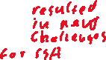

TT&C = Telemetry, tracking and control

TX = Transmit



USB = Universal serial bus

# Introduction



The reduction in economic and resource costs of designing, manufacturing, and launching a small satellite has led to an increased number of small satellites being launched and operated in the Low Earth Orbit (LEO) space environment[2]. A greater number of objects in the LEO environment has resulted in a decrease in space situational awareness (SSA) and an increase in the number of space debris, which leads to a larger reliance on resource expensive ground station monitoring equipment to maintain situational awareness in the LEO environment. The reduced cost of launching a small satellite into the LEO environment is a result of releasing multiple small satellites from a single launch platform, this is commonly known as ride sharing. Ride sharing has resulted in upwards of 100 small satellites being released from the same launch vehicle in a small-time frame[3]. This has resulted in a reduction in SSA immediately after the launch of small satellites and throughout their operational life cycle because of difficulties in identifying individual satellites. The difficulties of identifying small satellites in the LEO space environment results in a greater demand on the limited ground-based optical and Radar monitoring resources to maintain a reduced SSA capability. The standardisation of small satellite manufacture has reduced the cost of production allowing government, educational and commercial organisations with little to no space mission experience to create and produce small satellite designs to meet their organisations requirements. The unique development and design process to meet these organisations requirements for each satellite has resulted in a 55% failure rate for academic institutions and a 23% failure rate for commercial industry[4]. The cause of a small satellite failure is difficult to determine as the failure can reduce the amount of satellite telemetry data available for faultfinding. A deficiency of telemetry data can result in the determination of satellite failure being contributed to several causes of possible failure (typically 5-10 possible causes). The ride sharing launch produces additional difficulties in identifying an individual satellite immediately after release by the ground monitoring stations which leads to an increase in failure rates due to difficulties in creating the initial communication link with the individual satellite[5]. A satellite failure can cause that satellite to be uncontrollable and/or difficult to track causing it to become a space debris object. An increased number of space debris in the LEO environment diminishes SSA which leads to an increased risk of a collision for all users of the LEO space environment.

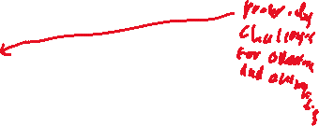

To increase SSA in the LEO environment and reduce the small satellite failure rate a solution needs to be investigated that aims to provide better methods of obtaining satellite telemetry data and provide a cost-effective method of tracking satellites and space debris in the LEO space environment.



The purpose of this project will be to design a self-sufficient, independent satellite radio beacon system that can transmit satellite identification and telemetry data and receive control commands using a UHF radio signal that is capable of being tracked using multiple geographically dispersed, cost-effective ground receiving stations.



The satellite radio beacon shall primarily allow for the identification of an individual satellite during launch and its operational life cycle providing greater SSA which leads to a lower risk of collisions in the LEO environment. Multiple graphically dispersed ground mounting stations constructed using low-cost, commercially available components are to be utilised to track the satellites beacons radio signal allowing the existing resource intensive ground-based monitoring systems to focus on other LEO space objects. The beacon will have a secondary function that can provide telemetry data for satellite on-orbit fault finding to facilitate the determination of causes of failure. Determining the actual cause of failure as opposed to having several possible causes of failure is expected to reduce the number of failures in future launches and operations. This system can be extended to include an alternative communications pathway that can be used to provide limited control of the other satellite sub-systems to offer a redundant system to correct on-orbit failures. Correcting an on-orbit failure can result in regaining control of the small satellite reducing the number of space debris objects in the LEO environment.



# Aim

The aim of this project is to design and produce a ground-tested satellite UHF radio beacon prototype and a cost-effective ground monitoring station prototype that can sustain a communications link for the distances required of a satellite in LEO. In order to achieve this aim, three aspects will be investigated, firstly the satellite radio beacon that is to be a self-sustained UHF communication system capable of operating independently of all other satellite sub-systems for the duration of the satellites operation mission (until deorbit). Secondly, the UHF communications link which must be able to support the reliable transfer of satellite identification and telemetry data up to 2000kms to support the operation and monitoring of satellites in the LEO space environment. Finally, the ground monitoring station which must be capable of capturing the satellites identification and telemetry data and recording the precise time of arrival of the radio signal and its positional location. The ground station will be able to pass on the captured data and measurements to a peripheral device for post processing.

# Background



The theory of operation of the satellite beacon system is that the beacon contains its own power, processing and radio subsystems to ensure that it is self-contained and independent for the satellite. Each radio beacon system contains a unique identifier in the form of 4 hexadecimal characters which allows for 65,536 combinations of addresses to be used simultaneously. Each radio beacon processor has the capability to be linked to other systems within the satellite to allow for the collection of satellite telemetry and health data or to pass a received command to another satellite system. The 4 hexadecimal satellite identification address and telemetry data are sent as a data packet via the beacon radio to a ground receiving station to uniquely identify the small satellite and provide satellite telemetry data for tracking and fault-finding purposes. The radio beacon can receive data from a ground receiving station to provide control of the beacon and emergency control of the small satellite.

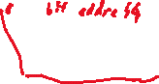

The ground station can receive and process the identification and telemetry data as well as providing a precise time of arrival of the received signal. The precise time of arrival for a unique small satellite being received at three globally dispersed ground receiving stations allows the position of the satellite to be calculated. The global position of each ground station must be known with each station being synchronized to the same clock timing to allow for the Time Difference of Arrival (TDOA) calculation technique to triangulate an approximate position as shown in below in Figure 1. The trilateration of position from three stations reduces the possible position of the satellite to two spatial locations with one being discarded as it would be below the surface of the earth.

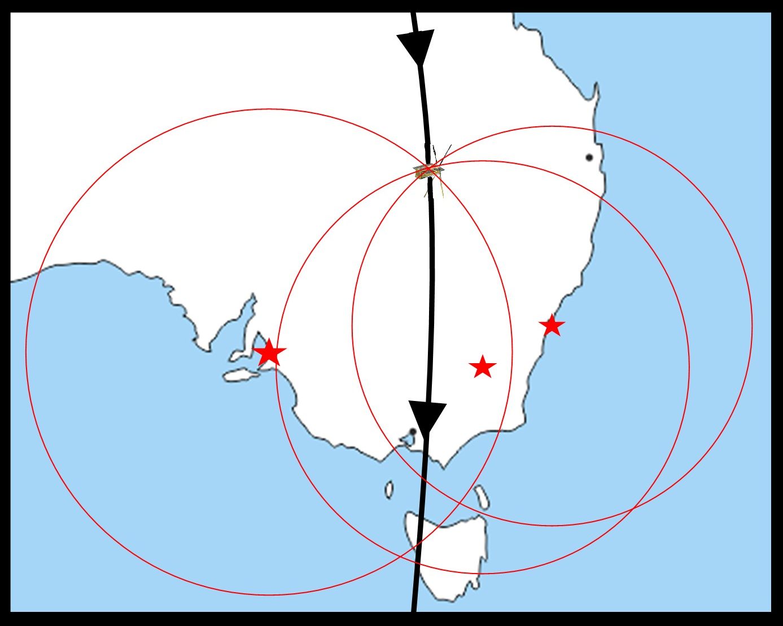

Figure 1 - Visual representation of TDOA trilateration with 3 stations   
(map source:<http://www.mapsopensource.com/australia-oceania-outline-map.html>)

A review of the current systems available has shown that solutions are provided for individual aspects of SSA in the LEO environment, but they do not take a holistic approach to key parameters of a satellite telemetry, tracking and control (TT&C) system. The key parameters of a TT&C system are satellite identification, telemetry, tracking and control. There are several systems that provide only identification (CUBIT, SOARS, Passive RF tag, ELROI and LEDSAT) or only telemetry (safety radio beacon) and some which provide identification and telemetry (HyELT, RILDOS and IRASAT1). The existing systems delivers solutions to one or two parameters of the TT&C system which address either, but not both, problems highlighted in the introduction. The proposed project will implement solutions for all four key parameters of a TT&C system that will address both problems presented.



The major orbital parameters that will be used for this project is based on a generic small satellite mission in the LEO environment. The most common orbits for a small satellite mission are a sun-synchronous orbit with an orbital height of 300-400kms and inclination of 52° or a sun-synchronous orbit with an orbital height of 500-800kms and inclination of 98°[6]. The orbital parameters used for testing were determined from a sun-synchronous orbit, with an orbital height of 500kms and inclination of 98° which results in an orbital period of roughly 90 minutes with the view window of each pass being in the region of 8-10 minutes with the satellite and ground station having a slant range of between 500 to 2000kms.



A key goal of this project is to ensure that the design of the ground monitoring station be carried out such that the costs, difficulty of construction and the difficulty in operating the equipment is minimized. The result of minimizing these components of the design will allow a broader spectrum of the public to create their own ground monitoring stations. If the public were to create their own stations, then this will be able to create a larger number of ground stations that are more geographically dispersed. This has a two-fold effect of increasing the footprint and reliability of the ground stations for better SSA as well as increasing the public awareness and engagement in LEO space operations.

# The present study

The design of the small satellite identification and TT&C system will be broken up in three major components: the satellite radio beacon, the communication link and the ground receiving station. The satellite radio beacon contains three sub-systems: (1) Computer processing, (2) Radio transceiver, and (3) Power generation, storage, and regulation. The communication link is a standalone component while the ground receiving station will be separated into four sub-components: (1) Computer processing, (2) Radio transceiver, (3) GPS module and (4) Positional calculation measurement.



## Satellite Radio Beacon



The first major component of the system to be investigated is the feasibility of a satellite radio beacon that is a self-contained system and independent of all other satellite systems. The beacon must contain its own processor, radio and power generation, storage and regulation system to ensure the it is self-contained and independent from all other satellite systems. The major constraint for the beacon design is that the electrical power generated can meet the electrical power requirements of each sub-system. The components used in each sub-system will be selected to ensure self-sufficiency, independence, cost-efficiency, ease of operation and minimization of size and weight.



### **Materials and Methods**

The first decision in the design process was to select the components for the initial design of the radio beacon with the focus being on components that have a low power consumption and meet the requirements of each sub-system. The solutions investigated for the processor were a Teensy based microcontroller (MC), an Arduino based MC, a raspberry PI and a FPGA board with the 3.3V, 8MHz Arduino Pro Mini module (APM) being selected for the initial design. The APM was selected as it fit all the requirements of the processor system, it has a proven space heritage, it is well resourced and can be operated with a low supply voltage and clock speed to reduce power consumption. The APM module contains an in-built power regulation system using a MC5205 Low Drop Out (LDO) voltage regulator which will be used in the initial design. Three radio systems that are capable of long-range communications were found during the initial investigation for the radio design solution: The LoRa spread spectrum system, SIGFOX Low-Power Wide Area Network (LPWAN) system and the NB-IoT LPWAN system. The LoRa system was the selected medium for the initial design for it a provided a superior Point-to-Point communications protocol, high immunity to noise and doppler shift, greater software support and can operate in the 70cm (430MHz, RFM96 module) and 33cm (915MHz, RFM95 module) band radio spectrum. A Lora module breakout board designed by Boyan Nedkov (<https://github.com/attexx/rfm9x_breakout_board>) was used to allow compatibility with a prototyping solderless breadboard,. Solar power is the only system considered for the power generation system due to the difficulties of operating other power sources (Lithium-ion batteries, hydrogen fuels cells, nuclear power, thermo-photovoltaic cells, etc.) in a space environment. The solar panel selected for ground testing is a 0.5W, monocrystalline silicon panel from Seeed which can produce a load output of 5.5V with a current of 90mA at 18% solar conversion efficiency. A capacitor-based energy storage system was selected for the initial design due to the launch isolation and ground testing requirements of a battery-based system.



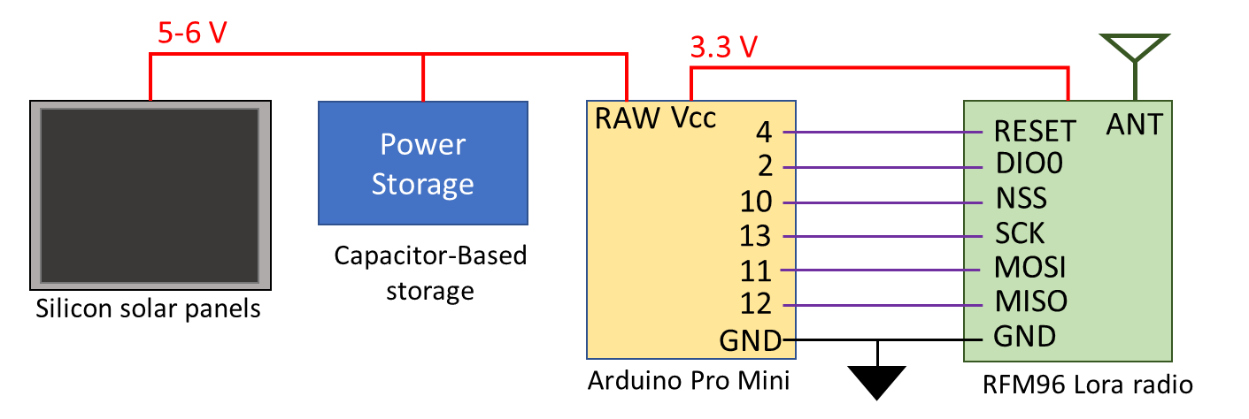

Figure 2 - Satellite radio beacon prototype design for initial testing

The initial design of the system was constructed on a prototyping breadboard (refer Figure 2 above) using Arduino IDE software to operate the APM module with the LoRa module software being driven by the Radiohead library developed by Airspayce (<https://www.airspayce.com/mikem/arduino/RadioHead/>). It was found during the initial testing of connections that the system required two solar panels to perform a successful transmit of the 50 Bytes of data when the LoRa module was set to the Radiohead default 0 settings and a transmit power greater than 10dBm. To ensure that beacon can meet the self-sufficient and independent requirements the initial focus of the testing was to minimize the current consumption of the beacon sub-systems. The first set of tests carried out were to support the investigation of minimizing the current consumption of the processing sub-system (APM module) with the testing method and results detailed in Appendix A. The next investigation was to determine methods of minimizing the current consumption of the LoRa module which was supported by the testing method and results shown in Appendix B. The next step in the design process was to develop the software that will be utilised in the satellite radio beacon which is based upon the software flow chart and design considerations in Appendix C. The final investigation for current consumption minimization was carried out on the power regulation system with the testing method and results presented in Appendix D. At the conclusion of the current minimization investigation, an investigation was carried out to determine the total current requirements of the radio beacon and methods to reduce the number solar panels required for the successful operation of the satellite radio beacon software cycle developed which is set out in Appendix E. The final investigation of the beacon was to design the power storage sub-system with the testing method and results shown in Appendix F.

### **Results**



Table 1 - Average current consumption for APM module processor and built-in regulator

The results for the testing of the APM module is detailed in Appendix A with a summary of the results shown above in Table 1. The results show a higher than expected current consumption measurement for the ATMEGA32P processor by approximately 10mA for all modes, which is attributed to a green surface mount LED that constantly consumes up to 10mA when power is applied. The results indicate that the current consumption of the APM module increases significantly if the supply voltage to the built-in regulator is increased from 3.3V to 5V. The current consumed by the APM module are shown to be reduced significantly when utilising the power saving modes of the *lowpower.h* library with the largest reduction in current consumption occurring when the *powerDown* or *powerSave* modes are utilised.



Table 2 - RFM96 LoRa module average current consumption for each mode of operation

The detailed results for testing the current consumption of each mode of operation for the LoRa radio module is in Appendix B with the measurements summarized above in Table 2. The results show that the RFM96 LoRa module consumes the smallest amount of current when it is in *sleep* mode and the largest in the *receive* mode (unless data is being transmitted).



Figure 3 - RFM96 module current consumption for Tx power level and transmission time for radio packet size results

The summarized result of the current consumption measurements detailed above in Figure 3 shows the LoRa module increases linearly (approx. 4.5mA/dBm) as the transmit power increases by 1dBm until 17dBm is reached in which the consumption plateaus at 117mA. The results indicate that the transmission time increases linearly by 10mS when the radio packet size increases by 5 Bytes when using the 0 default radio settings (medium data rate and range) in the RadioHead library.

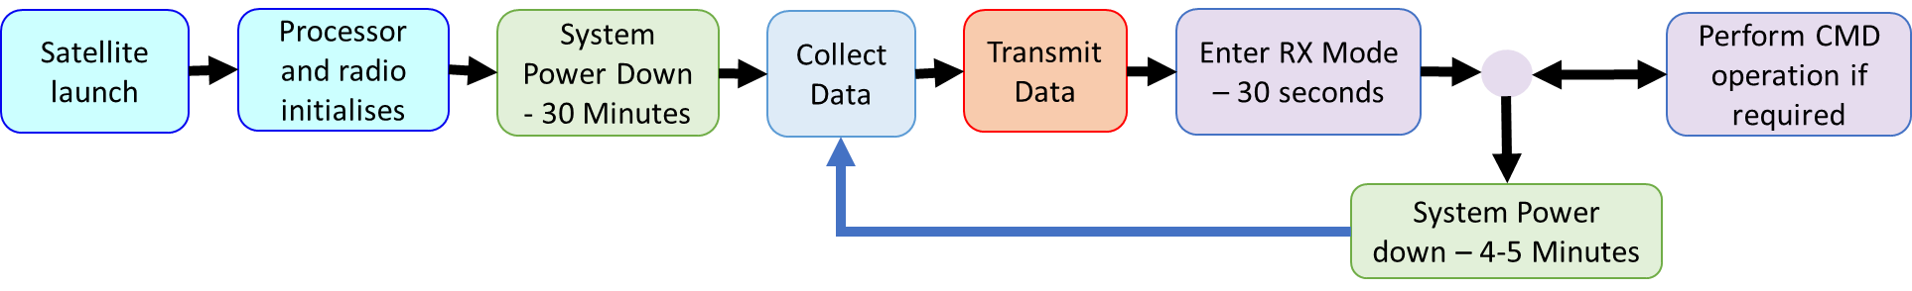

Figure 4 - Satellite radio beacon software cycle

The development of the software program for the satellite radio beacon is based upon the software cycle shown above in Figure 4 with the detailed software flow chart presented in Appendix C. The validation process of the software cycle discovered that a small number of packets were not being received by a second LoRa module (The transmission of the radio packet was verified using a RTL-SDR USB dongle driven by the Gqrx DR receiver software). A further investigation into the dropping of radio packets by the LoRa module receiver was carried out with the testing of the communications link. The APM module required 6 pins to be utilised (not including power, ground or connections for gathering telemetry data) for the successful operation of the satellite radio beacon software cycle developed. The basic software cycle developed using the Arduino IDE in which no telemetry data was collected resulted in the program using 8208 Bytes (28%) of the APM Flash memory and 1044 Bytes for global variables (50%) of the internal RAM, leaving 1004 Bytes for local variables.



Table 3 - Beacon total current consumption utilising different voltage regulators

The summarized results for the regulator testing is detailed above in Table 3 and reveal that the LM1086 and TS2940CZ LDO regulators have a much higher current consumption then the MC5205 LDO regulator and LM3671 buck converter during all phases of the software cycle. The inbuilt regulator and buck converter have similar quiescent currents throughout the software cycle except for during the transmit phase in which the LM3671 buck converter consumes 27mA less current.





Table 4 - Total current consumption measurements of the satellite radio beacon

The total current consumption of the satellite radio beacon for each phase of operation measured during the first test is summarized above in Table 4 with the detailed results in Appendix E. The testing procedure found that utilising 2 or 3 solar panels can sustain operation of the Satellite radio beacon through all the phases of the satellite beacon software cycle. The beacon software cycle could not be sustained when a single solar panel was being utilised if the transmit power level was set above 10dB without using an additional energy source. When 11mF of electrolytic capacitance was used to store additional energy to support the transmit phase then the radio beacon could be operated up to the maximum transmit power (23dBm) when connected to one solar panel.

If the electrolytic capacitors are replaced with a single 5.5V,1F super-capacitors then the beacon operation can be supported through all phases of the software cycle, but the super-capacitors introduce a delay to the start of the software cycle. If a single super-capacitor is used, then there is a 1-minute delay between when the solar panel start generating electrical power until there is enough energy to power all the sub-systems. When the number of 1F supercapacitors is increased to 5, then the results show an 8 minute and 20 seconds delay to initialize the radio beacon hardware and software in which the voltage potential of the capacitors being measured at 2.6V. The super-capacitor storage system reaches it full electrical potential after 27 minutes of operation when the software cycle is approximately 19 minutes into the low power launch phase. The average voltage potential of the super-capacitor storage system after a one charging cycle was 6.3V which equates to approximately 101 Joules of energy stored in the five capacitors. The super-capacitor storage system, when fully charged, can support 1 hour, 13 minutes and 43 seconds of beacon operations when no electrical power is being generated by the solar panels.



### **Discussion**

The results of the investigation into the minimization of the current consumption of the satellite radio beacon has shown that the beacon is a self-contained and independent of all other satellite systems. The testing carried out found methods to minimize the total current consumption of the sub-systems of the beacon:

1. Place the ATMEGA328P processor into *powerDown* or *powerSave* low power modes where possible and remove all surface mount LEDs
2. Place the LoRa radio into *sleep* mode where possible and reduce the length of the *receive* and *transmit* phase to the shortest time possible
3. Reduce the radio transmission power to as low as possible
4. decrease the size of radio packets to the smallest size to transfer data
5. Utilize a more efficient voltage regulator, LM3671 Buck converter

When all the current minimization methods were implemented into the satellite radio beacon, then one solar panel could not sustain operation of the beacon software cycle without using an electrical storage system to support the *transmit* phase. This led to the design of an energy storage system based using five 1F super-capacitors that can support a transmit power of 23dBm with one solar panel and can meet the no power storage requirements of the launch providers. The storage system allows for a minimum of 73 minutes of beacon operation when little to no power is being generated in low irradiance conditions and minimizes the space required of the satellite beacon by reducing the number of solar panels. The 8 minute and 20 second delay caused by the super-capacitors after power is applied can be included in the 30-minute period of radio silence after the satellite is released from the launch providers vehicle. The final design for the solderless breadboard-based satellite radio beacon prototype is presented below in Figure 5.

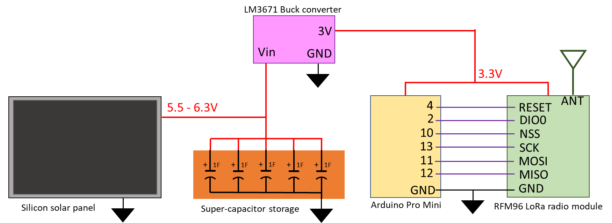

Figure 5 - Satellite beacon system configuration and connections for ground testing

The software cycle developed was based upon the software flow chart in Appendix C which must include a 30-minute period of radio silence immediately after release from the launch vehicle to meet the requirements of the launch provider. The radio beacon must have the ability to accept a command to silence the radio to meet the RF spectrum requirements set by the ACMA and ITU which dictates that the software cycle must contain a *receive* phase. The communication link testing is required to be carried out before the final software code is finalized to determine the LoRa radio settings and the format of the radio packet data.



The connections to the APM module required to operate the beacon are shown above in Figure 5 which allows for a combination of the follow connections to collect telemetry data:

* Up to 8 analogue (ADC) connections
* Up to 10 digital (GPIO) connections
* 1 UART serial connection
* 1 Two Wire Interface (TWI) connection
* 1 FTDI Header
* 4 Pulse Width Modulation channels
* 1 External Interrupt
* 2 Analogue comparators

The basic software program uses 8208 Bytes (28%) of storage space (flash memory) and 1044 Bytes for global variables (SRAM), leaving 22k Bytes of flash memory, 1k Bytes of SRAM and 1k Bytes of EEPROM for developing the program for collecting telemetry data.

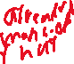

A waterfall design approach for the development of the satellite radio beacon system led to each component of the system to be researched, designed, tested and verified to ensure the beacon is self-sustained and independent. The cumulative results of the testing produced the initial design of the radio beacon (see Figure 5 above) which can be constructed using a solderless breadboard with the final software configuration to be determined after the communication link testing. The satellite beacon breadboard prototype was used to verify that the initial design meets all the previously stated requirements of the system with the next step in the design process being the verification of the communications link.

## Communications Link

The communications link between the satellite radio beacon and ground receiving station must be able to sustain the reliable transfer of data for the expected slant range for a satellite in LEO. The orbital parameters for the operational missions in the LEO environment determine that the maximum distance to be supported by the communications link is 2000kms which equates to a signal free-space path loss of 151.3dB. The transmit power of the LoRa radio module and radio configuration settings will be determined on the results of the link budget calculations.

### **Materials and Methods**

The first set of tests to be carried out for the communication link is to investigate the reasons the radio packets being dropped that was found during the software testing and determine if can be stopped or reduced. A detailed description of the methods used to carry out the testing is found in Appendix G with the tests first determining if changing the parameters of the RFM96 LoRa radio module or test conditions effects the number of packets dropped, which is known as the Packet Error Rate (PER). Secondly, a set of tests were conducted to analyze the data that is transferred to check if there are any Byte or Bit errors present in the transferred data. The last set of tests will utilize functions that monitor the quality of transmission and reception of data within the *RHGenericDriver.h* file that is inherited by the *RH_RF95.h* file utilised in the RadioHead library.



The next step in the communication link testing is to verify the transmission power and radio settings that will allow for the reliable transfer of data to a satellite in LEO. The first step was to determine the resultant receiver sensitivity and link budget for the default radio settings and the two long-range radio settings available in the RadioHead library using the LoRa modem calculator tool available from Semtech. A transmitter and receiver LoRa module were then connected with a series of cables and attenuators which simulate the Free Space Path Loss (FSPL) to verify the results of LoRa calculator and that reliable transfer of data for the distance expected in an low earth orbit mission. The methods used for testing and the results is detailed in Appendix G with the results and current RF regulations used to determine the radio settings and transmit power that will be used for the final testing.

The final step in the testing of the communications link is to perform all the necessary calculations to determine the link budget and compare against the estimates of the LoRa modem calculator tool. The compete method of how the communications link budget was calculated is detailed in Appendix H with the results of the budget determining what transmit power level will be selected for the prototype testing.



### **Results**

The investigation into the radio parameters and test settings show that the two settings that record a reduction in dropped packets is the CRC setting and the coding rate. In general, when the CRC setting is turned on or if the number of CRC check Bits are increased then the number of packets dropped is reduced. If the CRC is turned on, then the number of packets dropped can be reduced by up to 50% and if the number of CRC check Bits are increased from 1 to 4 then the reduction in dropped packets by 75% was observed. This reduction in the number of dropped packets is not observed consistently throughout the different testing parameters and as such is just a general observation with no trend being able to be identified. There was a total of 8 tests carried out that analyzed the content of each Byte which found that there were no Bit errors presence in 79.904 Bytes received. Using the functions within the *RHGenericDriver.h* file revealed that the reason for the LoRa module not being received cannot always be determined. For a tested sending 10,000 packets of data there were a total of 85 packets dropped when the CRC was on with 79 being determined to have errors and 6 not received at all and there were 12 packets dropped when CRC was turned off with 3 packets determined to have errors and 9 not received at all.





Table 5 - RadioHead Library default LoRa module settings with LoRa calculator Bit rate and receiver sensitivity estimates

A summary of the RFM96 LoRa radio module configuration from the RadioHead Library default settings with a Bit rate and receiver summary estimate from the LoRa modem calculator tool is presented above in Table 5. The initial table indicates that the 2 default settings could operate over a longer distance using a smaller portion of the radio spectrum with a comparable bit rate to the 3 default settings.



Table 6 - LoRa calculator Link Budget estimates and testing measurements for the RadioHead default settings

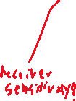



Table 7 - LoRa calculator transmission time estimates and testing measurements for the RadioHead default settings

The data presented above in Table 6 and Table 7 compare the estimated data from the LoRa calculator against the measured data obtained from the testing for the link budget and transmission times. The results indicate that the LoRa calculator link budget estimates are a fair representation of the measured results, while the transmission times were slightly unreliable. The results from the testing reveal that the (2) radio settings can sustain a communication link for a larger distance (1dB greater attenuation in the FSPL) for a smaller transmit time ( 40% less Time-on-Air) than the (3) settings. The results from the testing also indicated that there is an approximate 20% increase in Bit energy (Eb) when comparing the 2 default settings against the 3 settings.







Table 8 - Link budget calculations for the satellite beacon to ground station communications link

A detailed method of calculating the link budget is presented in Appendix H and summarized above in Table 8 which shows that the communication link for the LoRa radio module has a positive bit energy to noise density ratio () when using both long range settings in the RadioHead library. To maintain a reliable communications link, an ratio above 10 should be maintained which is achieved by setting the transmit power to 15dBm or above for both RadioHead long range settings.

### **Discussion**

The investigation to determine if the number of packets dropped can be reduced could not provide a set of radio parameters or test conditions that produce consistent results. The testing showed that only a portion of the packets not been received are rejected by the LoRa module (payload or header CRC check errors, checksum errors, bad lengths, etc.) with the rest not being received by the LoRa module at all (not detecting the preamble). At the conclusion of the testing, further investigation into the settings for the LoRa radio module was conducted to allow for the data that is received by the module to be passed to the Arduino for processing regardless of any errors present which found that the proprietary nature of the CRC method used by SEMTECH prevented any modification of the receive process.



The number of packets dropped by the LoRa module throughout the whole testing process was determined to be less than 1% of number of packets transmitted. To prevent the loss of all the data at the receiving station, is was decided that the transmitted identification and telemetry data will be separated as opposed to providing all the information in the one radio packet. The identification of each satellite was determined to be 4 hexadecimal characters (2 Bytes of data) with each identification radio packet containing 2 sets of satellite identification addresses and 1 Byte to identify the individual packets for a total of 5 Bytes of data. During each transmit phase of the radio beacon, the identification packet will be repeated 4 times followed by one packet of 50 Bytes containing the telemetry data. This transmission format was selected due to the inability of preventing radio packets from being dropped by the LoRa receiver. If a radio packet is missed, then the chances that the identification data is not collected is extremely small well as allowing multiple transmissions provide alternate signals to track if one is missed.



The investigation for the LoRa radio settings using the LoRa calculator suggests that the RadioHead (2) default settings is a better solution for this project when compared against the (3) settings. The results from the testing showed that the (2) default settings was able to sustain a reliable communications link for a larger FSPL loss showing that it can operate a link for a longer distance (the difference depends on the transmit power). The testing also revealed that a LoRa module with the (2) default settings has less Time-On-Air, occupies a smaller bandwidth on the radio spectrum and has a higher Bit energy. These factors contribute to the decision that the (2) default settings for the radio will be used for all further testing while the transmit power will be base on the calculation of the communications link budget.

The calculations for the link budget for this communications link show that there is a significant increase in the when using the long range settings from the RadioHead library with the (2) settings providing a higher ratio than the (3) settings. The (2) settings utilizes a smaller bandwidth (31.5kHz) as opposed to the (3) settings (125kHz) which results in the (2) settings having an approximate 20% higher energy per bit value as opposed to the (3) settings. The maximum transmitted RF power levels of the LoRa module are well below the maximum power level that can be transmitted on the 435-438MHz radio spectrum as stipulated by the determinations of the ACMA amateur license conditions. This allows the LoRa module to be used up to it’s maximum transmit power (23dBm) with the decision made to initially use a 15dBm transmission power on the satellite beacon to balance the satellites electrical power requirements with maintaining an Eb/N0 above 10.

The testing carried out on the communications link has determined that the RFM96 LoRa radio module operating at 437MHz can operate a reliable data link between a satellite radio beacon in LEO and a ground receiving station. The communication requires that the RFM96 LoRa module use the default (2) settings in the RadioHead library with a transmit power of 15dBm to maintain a bit energy to noise density ratio above 10 with the final form of the satellite radio beacon software code being presented in Appendix I. The testing found that the packet error rate of the LoRa module required that separate packets of data be sent to include a redundancy that ensures the satellite identification is received at the ground station for every transmit phase of the radio beacon software cycle.



## Ground Receiving Station

It has been shown that the communication link can support the reliable transfer of data between the satellite beacon and an Earth-based receiving station which leads to the design of the ground receiving station. The major constraint for the ground receiver is to produce a design using cost effective components that has an acceptable level of tolerance in determining the position of the satellite. The position of the satellite can be approximated using the time difference of arrival of the transmitted beacon radio signal at three ground stations which requires a common timing source between the stations and an accurate method of measuring time.

### **Materials and Methods**

The first design decision was to utilize the Global Navigation Satellite System (GNSS) in the ground receiving station to provide the geospatial location of the ground station, the Coordinated Universal Time (UTC) for a common timing source and a pulse per Second (PPS) signal for synchronizing the processor clock timing. The initial design of the ground receiving station will include a global positioning development module based on the U-Blox NEO-7M GNSS module as it has a positional accuracy of 2.5m, a 30ns PPS signal accuracy available on an external pin and cost less than $20. The NEO-7M GNSS module was paired with a 28dB GPS Antenna for signal reception which cost approximately $15.

The second design decision was to utilize the RFM96 LoRa module on the same breakout board as used in the satellite beacon prototype the radio communication. This allows the radio module to utilize the same software and libraries used in the beacon development to provide continuity between the two systems. The breakout board used in this design contains an SMA connector allowing for a simple 3.5dBi helix antenna or a 12dBi Dipole antenna to be used for testing with the total cost for the radio and antenna being approximately $22.



The last design decision before development begins was to select the computer processor that will be used to drive the LoRa and GNSS modules and can accurately measure time to a precision required for this application. The first decision limit the solutions to an Arduino based microcontroller board was made to ensure a processor was selected that is well resourced, has enough peripherals and is easy to use which reduces the available solutions to the Arduino Uno or Arduino Due. The Uno was selected for the initial design as the cost was substantially less with it being noted that the Due processor speed (84MHz) is much higher than the Uno processor (16MHz) which could increase the precision of time measurement if it is required. The initial design of the ground receiving station is below shown in Figure 6 with the total cost of components for the ground receiving station being under $80.

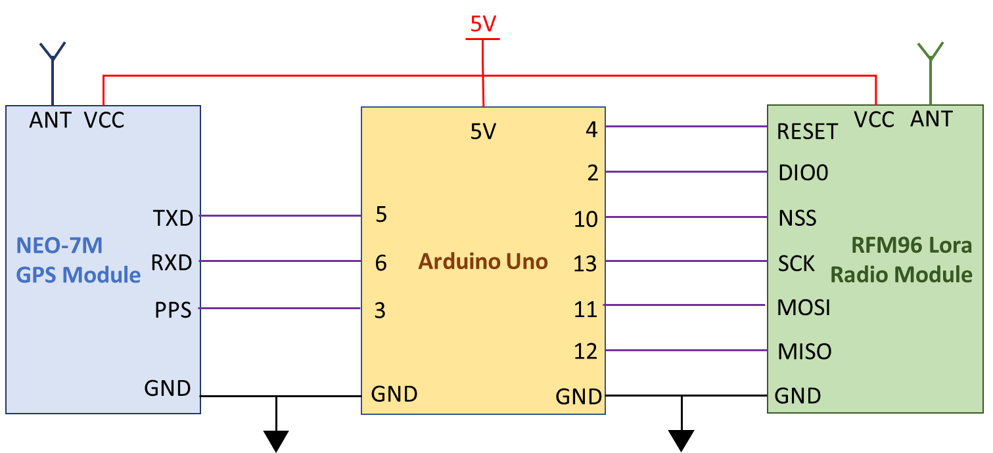

Figure 6 - Satellite ground receiving station design with connections

After the initial design decision were made, the next step was to develop the software code for the ground receiving station which is derived from the software flow chart detailed in Appendix J. The initial operation of the ground receiving station was planned such that as the ground station receives each packet (4 identification and 1 telemetry radio packet) it produces a time stamp that marks the time of arrival which is referenced against the arrival of the next PPS signal. The GPS data is then saved which contains the current UTC time to a second precision and positional data of the ground station. The number of clock cycles between each packet time stamp and the PPS signal is used to determine the precise time of arrival of each radio packet with relation to the GNSS provided UTC. The timestamps, GNSS data (position and UTC), the identification data and the telemetry data are then passed on to another device for further processing. The measured difference time of arrival, synchronization of GNSS UTC and known position of three ground receiving stations allows for the calculation of the approximate satellite position using a TDOA ranging technique.

The primary focus of testing the ground receiving station was to determine the possible sources of error in the parameters that would determine the accuracy of the satellites estimated position. The initial research and testing of the system identified the following sources of error that could produce an error in the measurement of distance between the beacon and ground station…

### The resolution of the Arduino built-in timer function, micros()

1. The number of clock cycles taken to carry out an Interrupt Service Routine (ISR)
2. Oscillator frequency drift due to temperature, tolerances and other sources of error
3. Tolerance of the GNSS PPS signal – 30ns
4. Accuracy of the ground station GNSS position – between 2-10m
5. The time taken for the LoRa module built-in software to carry out integrity checks (time between when the signal is received and when it is made available by the LoRa module) – unknown
6. The resolution of the ATMEGA328P processor clock cycles

A detailed description of how each error in measurement was investigated, tested and the results are presented in Appendix K. The results from the testing each error in measurement was combined to determine the total expected error in measurement between two ground stations. The final verification testing was carried out to verify the total expected error in measurement with the testing method and results shown in Appendix L.

### **Results**

The initial testing of the time measurement using the *micros()* function built-in to the Arduino IDE software reveled that the resolution of this measurement was found to be 4.096µs. The *micros()* function is implemented by Arduino has the output of the function being incremented only when the ATMEGA328P processor timer0 overflows resulting in the 4.096µs timing resolution which equates to distance calculation error of up to 1.23km.

The investigation into using the ATMEGA328P processor Timer1 to count the number of clock cycles between events revealed an error in the clock cycle count between successive events and the presence of a spike in the clock cycle count error (up to 190 clock cycles) occurring at irregular intervals. The spike in clock count error between successive events (timed at exactly 1 second intervals) is a result of the implementation of executing an ISR in which the ISR is not entered until the current block of software code being executed has been completed. The results presented in Appendix K show that the difference in clock counts between uniformly timed events was less than 3 clock cycles for 97.3% of the measurements. When the spikes in clock counts were removed from the samples then the resultant statistics shows the error in clock cycles between events has a mean of 0.0266 and standard deviation of 1.1636 which results in 95% of the measurements being between -2.30 and 2.36 clock cycles.

The investigation into how the ISR were carried out revealed that the method for entering the routine for counting clock cycles (Timer1 ISR, TIMER1_COMPA_vect) and measuring the GNSS PPS pulse (External interrupt ISR, INT1_vect) are exactly the same and uses the same amount of clock cycles to enter, execute and leave an ISR. The method of using ISR to count clock cycles is common between each ground station and does not affect the difference in time for the TDOA calculation.

The tolerances for the errors in the GNSS PPS signal (30ns) and the GNSS positional measurement of the ground station location (10m) were found to be acceptable as the error are much smaller than the errors in measuring time and no further testing was carried out.



The testing of the time difference in processing of two LoRa modules shows that the processing time difference has a mean of -0.1803µs with a standard deviation of 2.7966µs. The cumulative distribution function was used to determine that 92.36% of the measured values lie between -5µs and 5µs and 96.56% of the measured values lie between -5.5µs and 5.5µs.



Table 9 - Final verification testing total error in timing measurement between 2 ground station measurements

The results of the final verification testing are shown in Appendix L and summarized above in Table 9 and show that the absolute total error in timing measurement has a mean of approximately 380µs with a standard deviation of 520µs for the address packets and a mean of 419µs with a standard deviation of 634µs for the telemetry packet. This equates to 95% of the absolute measurement errors of the address packets being less than 1.5ms and 95% of the telemetry errors being less than 1.7ms which equate to a distance calculation error of 450km and 510km, respectively. If the absolute error in timing measurement is averaged between all five packets, then the mean is 395µs with a standard deviation of 150.2µs and 95% of the measured values below 0.9ms which is a distance calculation error of 270kms.

### **Discussion**

The initial method of measuring time using the *micros()* function built into the Arduino IDE found that the resolution of the timer (4.096µs) resulted in an error equating to 1.23km when calculating distance, which is too large a tolerance for this application. This prompted an investigation into a method that would reduce the size of error which was to utilize the counter of the Timer1 clock cycles in the ATMEGA328P processor which has a resolution of 62.5ns. The testing carried out determined that there was a tolerance of ±3 clock cycles (with 97% confidence) when using the clock counting method which equates to an error of 56.5m when calculating distance. When 4 PPS signals are averaged (4 timestamps with a ±3 clock cycles uncertainty divided by 3) then the uncertainty increases to ±4 clock which is used to determine the instantaneous oscillator frequency. This results in a very small tolerance (less than 2 fs) in the length of clock cycle calculation and can be disregarded in the distance calculation. The tolerance of the GNSS PPS signal is 30ns (distance measurement error of 9m) and the tolerance of the GNSS position is 10m which results in a total distance error of 19ms for the GNSS modules. The largest source of error is from the difference in time it takes for each LoRa module to process the same received radio packet. The tolerance in processing time was determined to be 5µs (with 92.6% confidence) which equates to an error in distance calculation of 1.5km.

The results of investigating the error in timing measurements indicated that each ground station will have a total distance calculation error of 75m for the GPS and Arduino module with the LoRa module introducing a 1.5km error for deviation in the radio processing times. The total error expected between two ground receiving stations is 1.575kms which equals a time difference of 5.25µs. The verification testing carried out between two ground stations shows the total error in timing measurement to be between 1.5ms and 1.7ms which equates to distance error calculation of 450kms to 510kms.

The initial investigation for the large error tested the two external interrupts (the GNSS PPS signal and the LoRa module *RXDone* interrupt) with the PPS signal found to be within tolerance while the LoRa module was found to have a processing timing difference of up to 30µs (most signal were betwenn5-15µs) which is 25µs greater that then the values found during testing. This increase of the LoRa processing time is equal to a distance calculation error or 9km which is much less than the errors found in the verification testing. The large spike in clock counting error found during testing of the clock cycle counting algorithm was never greater than 190 cycles which is equal to approximately 12µs or a distance calculation error of 3.5km which is much less than the final testing error but it may give an indication to the cause of the error. The determined cause of the spike in the clock counting test was found to be the time (and number clock cycles) for the program to finish executing the current set of instructions before it enters the interrupt routines. This number of clock cycles can be compounded as the complexity of the ground station receiver software increases the number of clock cycles occurring before the ISR are entered and the two external interrupts used in the program take precedence over the clock counting ISR. To determine the reason for large increase in error in counting clock cycles (1.5ms is equal to 24,000 clock cycles), an investigation into the method of implementing and calculating the clock cycles between events for the ground receiver station will be required with the software code developed for the ground receiving station being presented in Appendix M. This investigation to reduce the final error in timing measurement will be required to be carried out before the data acquired by the ground receiving station can be used in calculating the position of the satellite using TDOA.



# Conclusions

The aim of this project was to produce an initial prototype design for a self-contained and independent radio beacon that can transfer satellite identification and telemetry data from a small satellite in a low earth orbit to a ground receiving station. The project was then extended to include a tracking function using multiple dispersed ground station to determine the time difference of arrival position calculation technique to estimate the position of the satellite. The design of the satellite beacon was the step of the process with a focus on ensuring the beacons self-sufficiency, independence and minimizing the size of the beacon. The resultant initial prototype as presented above in Figure 5 was to designed, tested and verified to be capable of operating without input from any other satellite system, has the capability to be connected to other satellite systems to collect telemetry data, can accept and execute a command from a ground station and can sustain normal beacon operation in low-irradiance conditions using one ground-based silicon solar panel. The next step in the design process was to verify the satellite beacons LoRa radio communications link can reliably transfer data from a satellite in low earth orbit to a ground receive station. The calculation of the communications link budget was supported by testing carried out on communications link with showed that reliable communications can be supported for slant range distances of up to 2000kms., The satellites identification address is transmitted in 4 sequentially packets to ensure that the satellite can be positively identified due to the high packet error rate of the LoRa module discovered during testing. The initial design for the ground receiving station is shown above in Figure 6 with the initial ground testing showing that it is capable of receiving the satellite identification and telemetry data. The testing of the collection of the signal time of arrival data indicated that there was an uncertainty in time measurement used to calculate the distance between two ground stations and the satellite of 1.5kms. The final verification testing carried out demonstrated that the time of arrival data collected by two ground stations has a calculated distance uncertainty of 450kms. The concept of a small satellite radio beacon system has been proven for satellite identification, telemetry and control capabilities but further work is required to include tracking of the satellite.



# Recommendations

To conclude the initial design of the ground receiving stations and ensuring that the satellite beacon system has a tracking capability requires further study to reduce the level of uncertainty in the time of arrival between two ground stations. The focus of further study should be the software program developed for the ground receiving station is the most likely the largest contributor to the large error in measurement uncertainty.

The reduction of the uncertainty to an acceptable level will allow for the development and verification of tracking the satellite by using the differential time of arrival at multiple ground stations to calculate the satellites position. This will require the development of a TDOA algorithm that estimates the position of the satellite within the determined uncertainties using the latitude and longitude position of the ground stations.

The next step in the development would be to develop a computer server system to transfer the required data between globally dispersed locations and to develop a graphical user interface for the display of the satellite position.

The satellite radio beacon requires further investigation into the electrical components utilised in the satellite radio beacon to ensure it is capable of operating in a space environment and to develop a printed circuit board design to enable full ground testing for space operations.



# Acknowledgements

Firstly, I would like to thank my wife, Christine and children for their unquestionable love and support throughout my studies and particularly through this thesis project. I would not have been able to complete my studies without the time, support and understanding that they have provided through some demanding times.

I extend my heartfelt gratitude to my thesis supervisors, Dr Edwin Peters and Dr Craig Benson, for their guidance and support through the completion of this thesis project. The brainstorming provided by Dr Craig Benson help to creatively shape the concept, which could only transform to reality with the time, dedication, knowledge and experience provided by Dr Edwin Peters.

I would like to extend my gratitude to Darryl Budarick of the Technology Support Group at UNINSW Canberra for the guidance, support and feedback in developing the hardware for this project.

# References *All references to be redone when work complete*

1. PLTOFF, School of Engineering & Information Technology. ZEIT4500.
2. DELPOZZO, S., WILLIAMS, C. & DONCASTER, B. 2018. 2019 Nano/Microsatellite Market Forecast. 9.
3. WEKERLE, T., PESSOA FILHO, J. B., COSTA, L. E. V. L. D. & TRABASSO, L. G. 2017. Status and Trends of Smallsats and Their Launch Vehicles An Up-to-date Review. *Journal of Aerospace Technology and Management,* 9**,** 269-286.
4. VENTURINI, C. C. 2017. Improving mission success of CubeSats.
5. KELSO, T. S. 2017. Challenges identifying newly launched objects. *Proceedings of the International Astronautical Congress, IAC,* 6**,** 3898-3903.
6. POPESCU, O. 2017. Power Budgets for CubeSat Radios to Support Ground Communications and Inter-Satellite Links. *Ieee Access,* 5**,** 12618-12625.